UNIT 4

Topic 8: BUSINESS TRADE CYCLE

- the concept of the business cycle
- characteristics of the phases, and causes, of the business cycle
- the relationship between the business cycle and economic indicators

Define the business trade cycle.

Describe, in detail, each of the four phases of the business trade cycle. (Hint: Reference at least 4 indicators in your description.)

Explain the causes of the business trade cycle, i.e. explain why the Australian economy would experience fluctuations in economic activity despite the government’s efforts to stabilise the economy.

Explain the turning points in the Australian economy:
- Explain why a boom will not be sustained indefinitely.

- Explain why an economy will come out from a trough.

Topic 9: AGGREGATE EXPENDITURE

- the components of aggregate expenditure (AE)
- consumption
- planned investment
- government spending
- net exports
Define each of the components of aggregate expenditure. Ensure that you give an example for each.

- factors affecting each of the components of aggregate expenditure
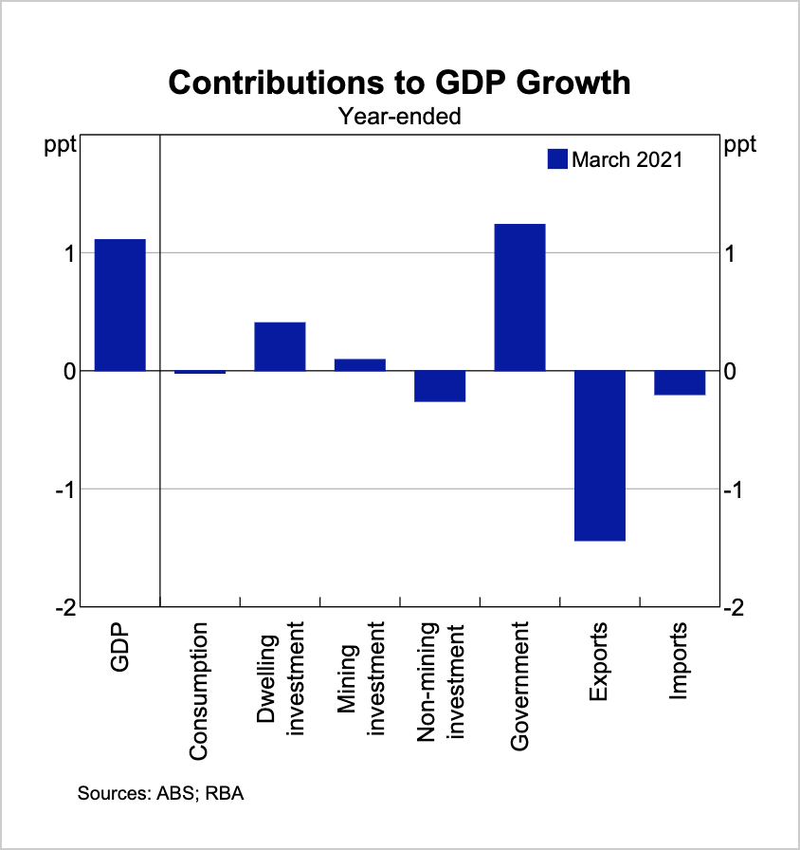
- With reference to the graph above, state the component making the largest contribution to GDP growth in the year ending March 2021. (1 mark)
- Calculate the contribution of net exports to GDP growth. (1 mark)
- Explain the change in net exports in the year ending March 2021 (2 marks)
- Suggest reasons for the increase in government spending. (3 marks)
- Describe and explain the contributions to GDP of dwelling investment. Hint: Consider contemporary policies that have been implemented. (3 marks)

State and explain the factors affecting:
- Consumption (min. 3 factors)

- Planned Investment (min. 3 factors)

- Net exports (min. 3 factors)

- Government spending

- the relationship between the consumption function, the marginal propensity to consume and the marginal propensity to save
State the consumption function.

Define the marginal propensity to consume.

Explain the relationship between the marginal propensity to consume and the marginal propensity to save.

Explain the factors that would shift the consumption function (i.e. factors other than disposable income).

- the concept of macroeconomic equilibrium
Explain and demonstrate the concept of macroeconomic equilibrium. Refer to inventories in your answer.

- demonstrate the impact of changes in aggregate expenditure on the equilibrium level of income/output using the AE model
- the impact of changes in each of the components of aggregate expenditure i.e. the multiplier process using the AE model
Describe the multiplier process.

Describe the impact on aggregate expenditure of:
- An increase in consumption spending
- A decrease in planned investment
- A decrease in government spending
- An increase in net exports

Demonstrate and explain the impact of decreasing interest rates on the Australian economy.

Demonstrate and explain the impact of Jobkeeper and additional government spending on the Australian economy.

Demonstrate and explain the impact of an depreciation in the Australian dollar on the Australian economy.

Topic 10: AGGREGATE DEMAND AND AGGREGATE SUPPLY

- the aggregate demand (AD) curve and factors that can cause movements along and shifts of the AD curve
Define aggregate demand.

Describe the reason for a movement along the aggregate demand curve.

Describe the factors causing aggregate demand to change.

- the aggregate supply (AS) curve and factors that can cause movements along and shifts of the AS curve
Define aggregate supply.

Describe the reason for a movement along the aggregate supply curve.

Describe the factors causing shifts of the aggregate supply curve.

- demonstrate macroeconomic equilibrium using the AD/AS model
- demonstrate the impact of changes in aggregate demand and aggregate supply on the equilibrium level of income/output using the AD/AS model

Demonstrate and explain the impact of a falling Australian cash rate on the Australian economy.

Demonstrate and explain the impact of falling oil prices on the Australian economy.

- the use of the AD/AS model to explain the business cycle
Using the AD/AS model, demonstrate the characteristics of a boom phase.

Using the AD/AS model, demonstrate the characteristics of a trough/early upswing phase.

Topic 11: ECONOMIC POLICY OBJECTIVES

- the economic objectives of the Australian Government
- sustainable economic growth
- low inflation (price stability)
- low unemployment (full employment)
- a more equitable distribution of income
- the efficient allocation of resources
Explain each of the economic objectives of the Australian government and describe if we are currently meeting them. Refer to the current economic climate and how that will influence the economic objectives.

- the economic policy objectives of the Reserve Bank of Australia (RBA)
Explain each of the economic policy objectives of the RBA.

- the extent to which the economic objectives of the Australian Government may conflict and complement each other
Explain the extent to which the macroeconomic objectives may conflict and complement each other. (Hint: Consider both RBA and Government objectives)

- the time lags which occur in the use of economic policies i.e. recognition, decision (implementation) and effect (impact) lags
Define recognition lags.

Define decision lags.

Define impact lags.

Topic 12: FISCAL POLICY

- the concept of fiscal policy
Describe the concept of fiscal policy.

- the components of government revenue and expenditure in the budget
Describe the main components of government revenue and government expenditure.

- the different budget outcomes i.e. balanced, surplus and deficit budgets
Distinguish between the different possible budget outcomes.

- reasons that account for differences between planned and actual budget outcomes
Account for the difference between planned and actual budget outcomes.

- methods of financing a budget deficit and the uses of a budget surplus
Describe the methods of financing a budget deficit. (Elaborate on any side effects of the methods.)

Describe the uses of a budget surplus. (Elaborate on any side effects of these uses.)

- the distinction between automatic fiscal stabilisers and discretionary fiscal policy
Describe the difference between automatic stabilisers and discretionary fiscal policy.

- the distinction between budget outcomes associated with automatic fiscal stabilisers and budget outcomes associated with discretionary fiscal policy
Explain why automatic stabilisers are considered to be the cyclical component of the budget outcome.

Explain why discretionary fiscal policy is considered to be the structural component of the budget outcome.

Explain how a budget outcome can be influenced by automatic stabilisers. Refer to examples.

- the concepts of expansionary, contractionary and neutral fiscal policy stances
Describe and explain expansionary fiscal policy.

Describe and explain contractionary fiscal policy.

Describe and explain neutral fiscal policy.

- the impact of different fiscal policy stances on the level of economic activity
Using an appropriate model, demonstrate and explain the impact of contractionary fiscal policy on the Australian economy.

Using an appropriate model, demonstrate and explain the impact of expansionary fiscal policy on the Australian economy.

- strengths and weaknesses of fiscal policy
Evaluate the strengths and weaknesses of fiscal policy.

- contemporary (the last three years) fiscal policy stances in Australia
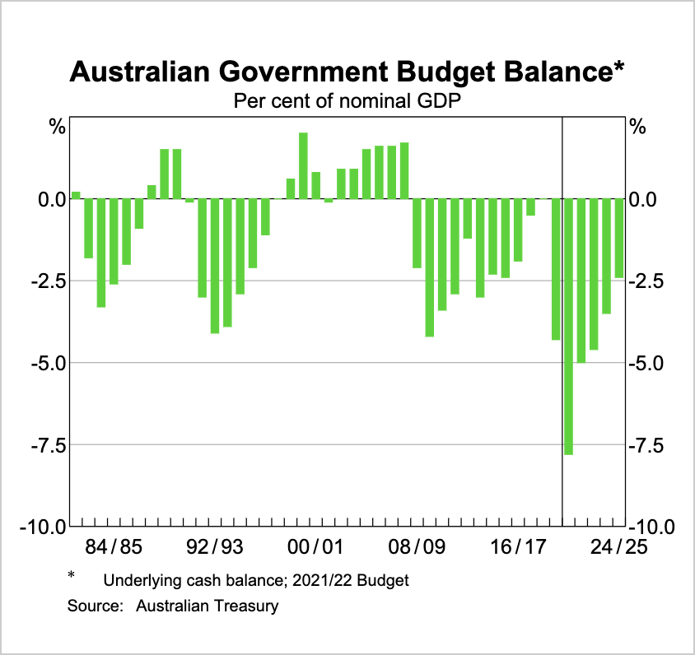
With reference to the graph above, describe the contemporary fiscal policy stances in Australia.

Topic 13: MONETARY POLICY

- the concepts of monetary policy and the cash rate
Describe the concept of monetary policy.

Define the ‘cash rate’.

- circumstances under which the RBA may change the cash rate
Explain why the RBA might lower the cash rate target.

Explain why the RBA might raise the cash rate target.

- how monetary policy affects the level of economic activity i.e. the transmission mechanism
Define the ‘transmission mechanism’

Describe the four channels of the transmission mechanism:
- Savings and investment channel

- Cash flow channel

- Asset prices channel

- Exchange rate channel

Evaluate the extent to which each of the channels will influence the level of economic activity.

- the concepts of expansionary, contractionary and neutral monetary policy stances
- the impact of different monetary policy stances on the level of economic activity

The global economy is experiencing a severe contraction as countries seek to contain the coronavirus. Even though the worst of this contraction has now passed, the outlook remains highly uncertain. The recovery is expected to be only gradual and its shape is dependent on containment of the virus. While infection rates have declined in some countries, they are still very high and rising in others. International trade remains weak, although there has been a strong recovery in industrial activity in China over recent months.
The Australian economy is going through a very difficult period and is experiencing the biggest contraction since the 1930s. As difficult as this is, the downturn is not as severe as earlier expected and a recovery is now underway in most of Australia. This recovery is, however, likely to be both uneven and bumpy, with the coronavirus outbreak in Victoria having a major effect on the Victorian economy. Given the uncertainties about the overall outlook, the Board considered a range of scenarios at its meeting. In the baseline scenario, output falls by 6 per cent over 2020 and then grows by 5 per cent over the following year. In this scenario, the unemployment rate rises to around 10 per cent later in 2020 due to further job losses in Victoria and more people elsewhere in Australia looking for jobs. Over the following couple of years, the unemployment rate is expected to decline gradually to around 7 per cent.

Adapted from RBA monetary policy statement in August 2020

- State the RBA’s inflation target.
- Using evidence from the extract, suggest the monetary policy stance that should be taken.
- Demonstrate and explain the impact of the monetary policy stance suggested in part (b).

Explain and demonstrate the impact of contractionary monetary policy on the economy.

- strengths and weaknesses of monetary policy
Explain the strengths of monetary policy.

Explain the weaknesses of monetary policy.

Evaluate the strengths and weaknesses of monetary policy.

- contemporary (the last three years) monetary policy stances in Australia
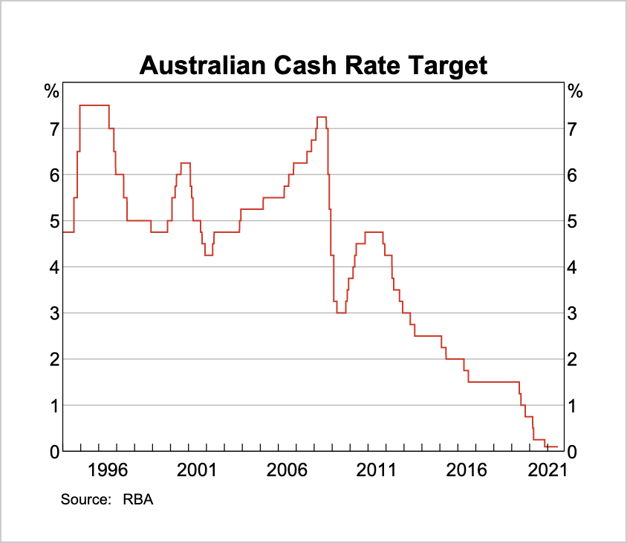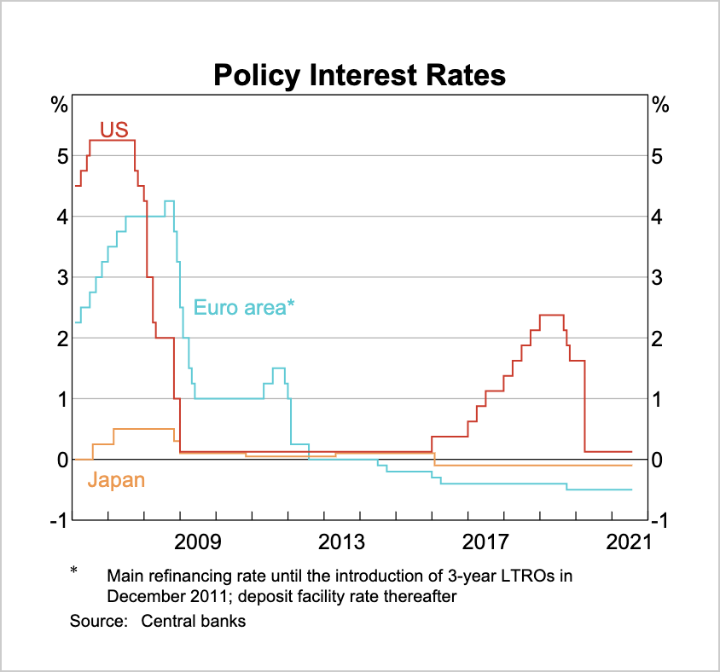

- State the current Australian monetary policy stance.
- Contrast the Australian monetary policy stance with that of US monetary policy in 2018.
- With reference to the policy interest rates from 2015-2020, explain the impact of the changing interest rate differentials between Australia and the USA.
- Explain the contemporary monetary policy stance in Australia.

Topic 14: STRUCTURAL CHANGE

- the concept, and main causes, of structural change
- the effects of structural change
- the relationship between economic growth and structural change
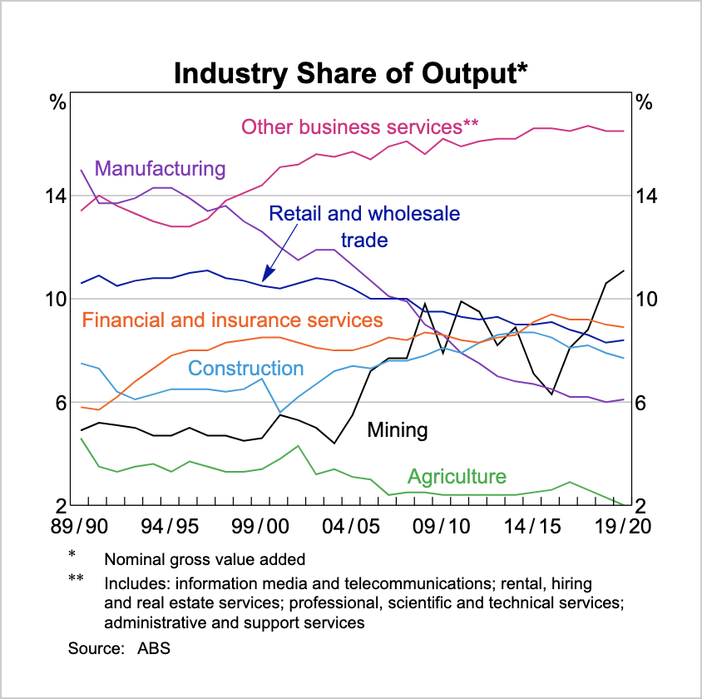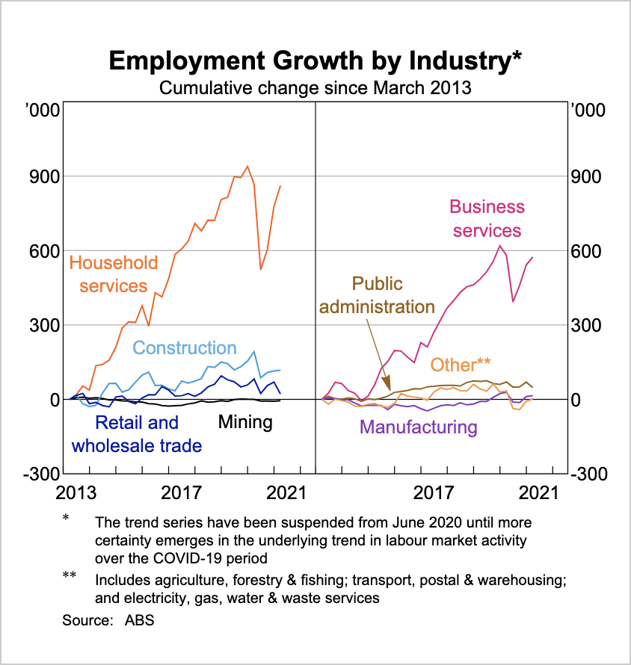

- Define structural change.
- With reference to the graphs above, describe and explain the structural change that has taken place in Australia over the last 10 years. (Hint: Should have at least 3 different observations)
- Describe three impacts of structural change on the Australian economy.
- Demonstrate and explain the relationship between economic growth and structural change.

Topic 15: MEASURES TO IMPROVE PRODUCTIVITY

- the concept of productivity
- the distinction between labour productivity and multifactor productivity
- the relationship between productivity and economic growth
- the impact of productivity on the achievement of macroeconomic objectives
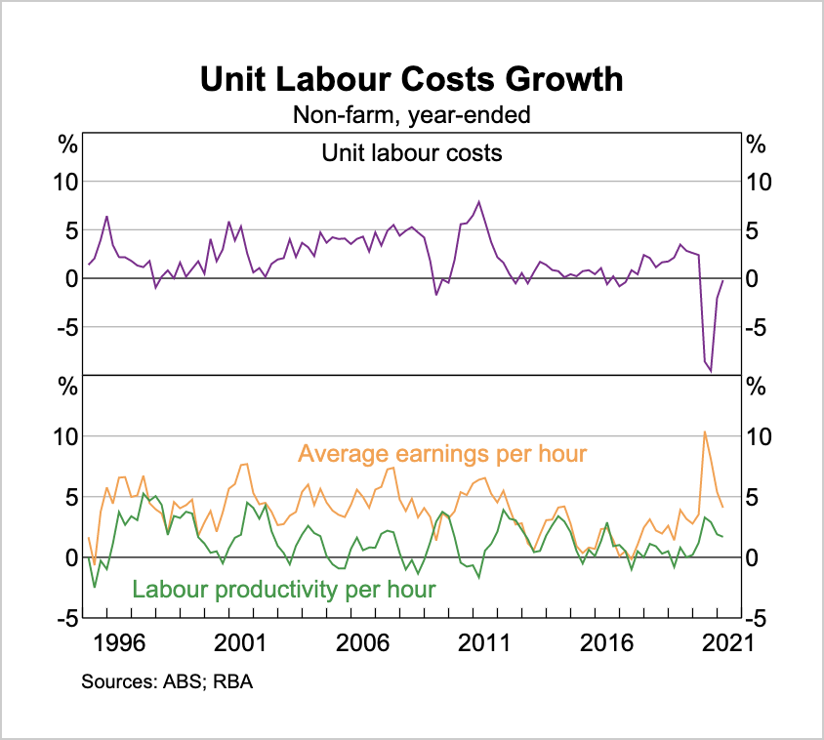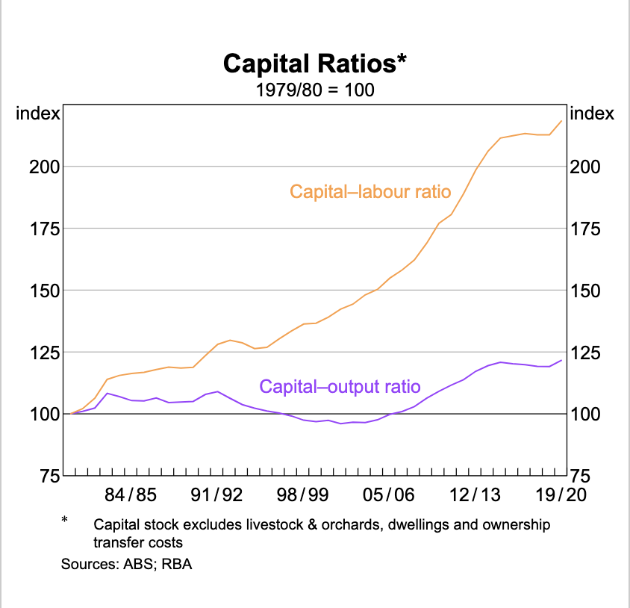
- Describe the recent trends in labour productivity in Australia.
- Describe the concept of productivity and define labour productivity.
- Describe the recent trends in capital-labour ratio. Explain how this would affect multifactor productivity in Australia.
- Demonstrate and explain the relationship between productivity and economic growth.
- Demonstrate and explain the impact of productivity on the achievement of Australia’s macroeconomic objectives.

- recent (the last ten years) government policies that promote productivity and economic growth, such as labour market reform, taxation reform, trade liberalisation, deregulation and competition policy, investment in infrastructure, education and training, research and innovation

For each of the following areas, explain government measures that have been implemented and how they can influence productivity.
- Labour market reform
- Taxation reform
- Trade liberalisation
- Deregulation and competition policy
- Investment in infrastructure
- Education and training
- Research and innovation

